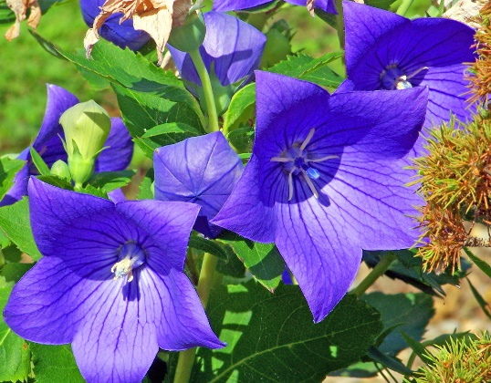

REVEREND LA WANDA DENISE POPE
Matthew 5:8 says, “Blessed are the pure in heart for they shall see God.”
Reverend La Wanda is a woman of God who loves the Lord with all her heart, soul, mind, and strength. She is a joyful daughter, wife, mother, grandmother, mother-in-love, and Godmother who has room for more.
Reverend La Wanda is an Itinerant Minister in the 4th Episcopal District of the African Methodist Episcopal Church, spiritual daughter of retired General Officer, Dr. James C. Wade, and the Founder and Lead Ministry Coordinator of Pure At Heart Ministry, a ministry empowered by The Holy Spirit, chosen to bring healing and wholeness to families, one heart at a time.
Reverend La Wanda is thankful and grateful God has blessed her to teach, preach and serve Him by reaching the masses in and out the country, fulfilling the Great Commission. God Has opened doors for souls to be saved, delivered, and set free, the hungry to be fed, the needs of the unsheltered to be housed, and to meet the needs of the under-served.
Reverend La Wanda’s special posture is the posture of prayer, and she genuinely believes prayer changes everything! Reverend La Wanda loves listening to God and works extremely hard to be obedient. She always says, “Help Me Lord and Lord Help Me in My pursuit of obedience.”
Reverend La Wanda wants everyone she comes in contact with and the world to know, there is a God Who loves you and, Who sent His only Begotten Son, that whosoever believes in Him shall not perish but have everlasting life. For God sent His Son, Jesus not to condemn the world, but the world through Him might be saved.
To Know God is to Love God and when you get to know Reverend La Wanda, you get to know God and love Him with all your heart, soul, mind, and strength.

